Data processors
Basics
Data processor in 1C is a separate configuration object designed to perform some program actions. It can be used to analyze data, work with documents, upload and download information, perform complex calculations, administrative actions with the information base and much more. Unlike most metadata objects, processing is not associated with database tables and does not allow storing information in the database, but performs the function embedded in them by the developer, that is, it is a tool for performing the actions embedded by the developer in the hands of users.
Types of data processors
Data processors can be divided into two main types:
1. Built-in data processors - included in the configuration and included in the scope of other metadata objects.
2. External data processors - stored separately as files and can be connected to any infobase without changing the configuration.
Additionally, data processors can be classified by purpose:
• Service - for database administration or calling from other subsystems, for example, generate or delete data, change the user password, etc.
• Additional interface solutions - to improve the usability of the system, for example, the user desktop, configuration overview…
• Data processing – for batch changes in the database, for example, changing product prices, entering opening balances, month closing operations.
• Data exchange – for importing/exporting data, for example, working with Excel, XML, JSON.
Example
Let's create a data processor for loading data from an Excel file. The data will be product prices. Since my configuration currently does not have a mechanism for setting item prices from specific dates, I need to implement such a mechanism. A periodic information register is best suited for storing such information. It is better to immediately include the ability to set several types of prices (wholesale, retail, partner) for the same items, since this is a common scenario for setting prices.
I create a catalog "PriceTypes", include it in a new subsystem "Prices" (which I just created), subordinate to the Sales subsystem. Next, I create an independent information register "ProductPrices" with a periodicity of Day and the following structure:
Dimensions: PriceType, Product
Resources: Price
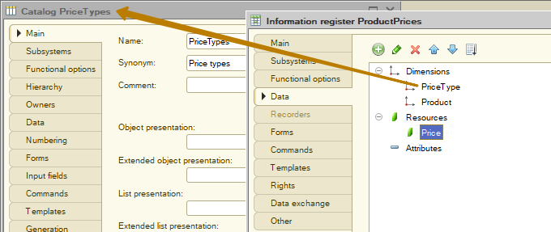
Now I create a new data processor "Import prices from Excel", which I place there, in the "Prices" subsystem. Then I create a data processor form and add the PriceType attribute to it with the type CatalogRef.PriceTypes, which I make mandatory to fill in
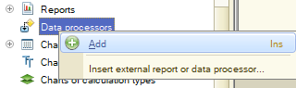
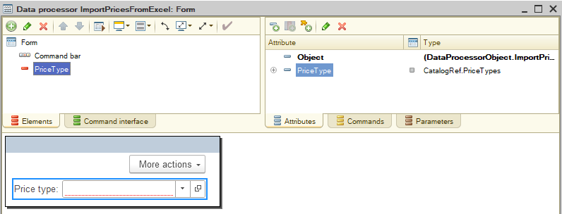
I need a spreadsheet document on a form for 2 purposes:
1) A spreadsheet document provides the ability to upload file contents and unload spreadsheet data into OpenOffice and Excel files, these are files with the extensions .ods, .xls, .xlsx, .xlsm;
2) It will allow us to see the contents of the uploaded file in our system, which is convenient for the user - to check the contents before uploading data to the system.
As part of the current task, I will not add support for OpenOffice files, support for Excel files is enough. I create the SpreadsheetDocument attribute with the appropriate type, add an element to the form and turn off the display of the title for it.
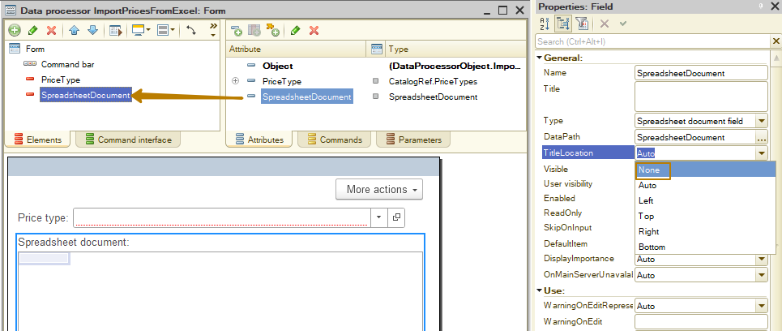
I also set the ReadOnly property for the spreadsheet document to True so that it does not allow manual editing by users, but only displays the information read from the file.
Next, I need to add a field with the path to the uploaded file to the form and implement the selection of a file for the user by pressing the choice button. Therefore, I create a PathToFile attribute with the String type and a length of 200 characters, I also make it mandatory to fill in, after which I transfer the field to the form and enable the choice and clear buttons for it.
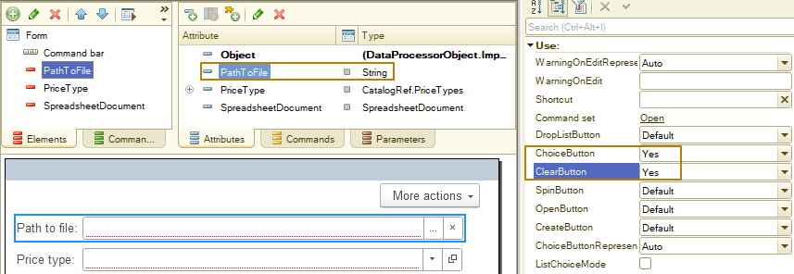
I need to create my own choice event handler so that when a user presses the choice button, a system window for selecting a file opens, where the user would select a file of only the specified types.
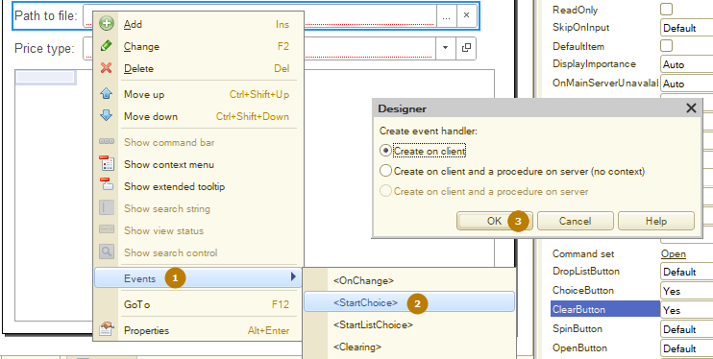
You are already familiar with the FileDialog object, which allows users to select a file or directory, as well as select the full name of a file to be saved. Let's use this object to implement the selection of a file to be downloaded.
First, I create a FileDialog object with the Open mode specified, then I specify the title - this is the inscription that a user will see in the window being opened. Then I set a file type (extension) filter so that a user selects only from among the files that are supported by my data processor, these are .xls, .xlsx, .xlsm files. I create 3 filters:
- Common for all three extensions
- Excel 1997-2003 for files with the .xls extension
- Excel for files with the .xlsx, .xlsm extensions
The last step is to call the Show method, which opens the system file selection window. The method itself must be passed a callback handler description, which will be called when the window is closed.
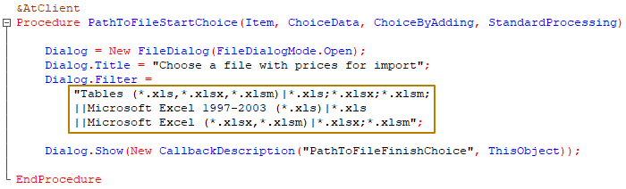
Note: filters are separated by the "|" symbol, just as the line break of a string value is performed by this symbol, so in my code you can see a double "||" symbol at a new line, the first of them allows to continue a string value at a new line, and the second acts as a separator in the filter. If I were writing the whole construction in one line, I would write a single "|" symbol.
In the callback handler, I check that the SelectedFiles variable is not equal to Undefined, which happens when a user closes the window without selecting a file. If a file is selected, the variable is of the Array type, which contains the full paths to the selected files (there may be several files if the "Multiselection" property is True for the file dialog). The file name should be obtained from the first element of the array.
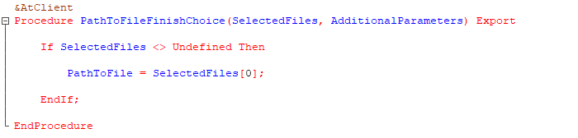
Now I need to describe reading data from a file into a spreadsheet document. As I already said, the SpreadsheetDocument has methods for reading a file and saving it to a file. We will use the Read(FullPathToFile) method to read a file, which will be called by clicking the Read button. I create the "Read" command, create its handler on the client and a procedure on the server, since the Read() method is not available on the client. I add a button to the form and write a simple code in the server procedure:
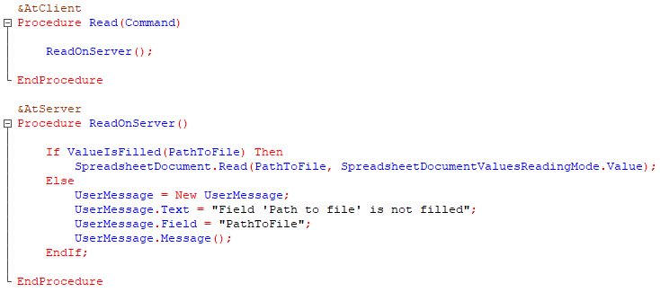
The MessageToUser object is used to display the same error message that the platform displays if it finds unfilled fields during the fill check. Messages displayed using this object focus attention on the fields specified in the "Field" property of the object, and also provide the ability to navigate between such fields using arrows (if there is more than one field).
As a result, in addition to the message in the message panel, a user also sees a pop-up message indicating a specific field:
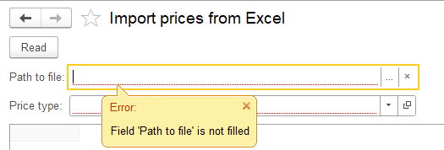
Now I select the file I created, click the Read button and see that the data has been successfully read from the file into a spreadsheet document
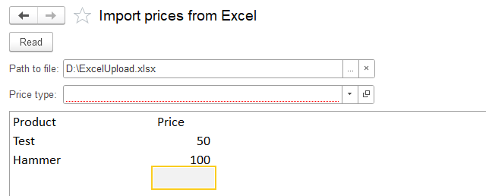
In the following step I need to implement the logic of reading data from a spreadsheet document, searching for a product in the catalog by its name from a file, and writing price data to the information register.
First, I create the "LoadPrices" command, a handler on the client, and a procedure on the server. Make the button for this command the default button.
In the procedure, the first thing to do is to check the filling of the mandatory attributes, in our case, the PriceType is mandatory, but you can check the filling of all mandatory attributes using the CheckFilling() method, then the platform will take over the check.
The next step is to determine the width and height of the table from the spreadsheet document in order to understand how many columns and how many rows of the spreadsheet document contain data (accordingly, we will iterate over only these rows and columns in the code). To do this, use the TableWidth and TableHeight properties of the spreadsheet document. Next, I perform a check: if the number of rows or columns is less than 2, then I need to display an error message to a user and stop executing the code, since the columns must be at least Product and Price, and 2 rows are needed because one of them is the column headers, so the presence of 1 row indicates the absence of product price data.
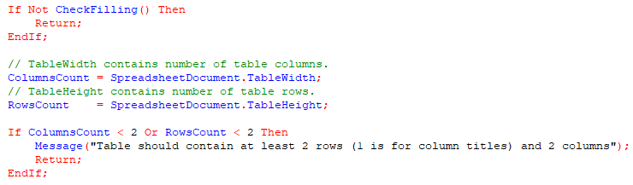
Now to the question of determining which table columns contain the data we need. There are several implementation options here, the most commonly used of them:
- the columns contain names and these names must be from among the predefined ones. For example, the column that contains product price data is called "price" (letters can be in any case)
- the user specifies the column numbers in special fields of a data processor, for example, if the product is contained in the first column of the table, the user sets the value "1" of the "ProductColumnNumber" attribute, the value "2" of the "PriceColumnNumber" attribute, etc. Then the columns themselves may not contain headers, and instead of comparing the column header with a predefined value ("Product", "Price", etc.), a check should be performed for the presence of a column with the specified number in the table.
I will demonstrate an example with column headers in a table, since it requires fewer actions from the user (no need to open the file, look at the column numbers, especially since the columns are numbered with letters, not numbers. Then these numbers need to be entered into the fields, and they can make a mistake), instead, the requirements for the format of the downloaded file are increased.
First, I create a variable ColumnNumbers with the Structure type, in which the keys will be the names of the required columns, and the values will be their numbers in the table.
After that, I loop through the table column numbers from 1 to the number of columns, where I get the text from the cells of the spreadsheet document using the Area() method. You should pass a cell region to this method, just like you would to the GetArea() method that we already knew from the lesson on print forms. So I pass <"R1C" + i> to it to get the cell in the first row and column with the number from the i variable. Next, I read the text from the resulting cell using the Text property and remove insignificant characters, such as a space, from the left and right using the TrimAll() method.
I look for the extracted column name in the ColumnNumbers structure, and if I find it, I fill the property with the current column number (a value of the "i" variable). If the name from the table header is not found in the mandatory columns structure, I display a message to a user that a column with that name and number will be skipped when loading from a file.
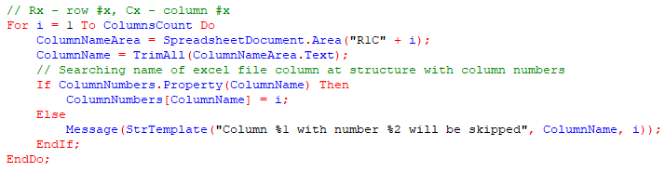 After I check all the table column headers, I need to check if all the mandatory column numbers are filled in. If they are not, the loading should be interrupted with an error message to the user.
To do this, I check all the properties of the ColumnNumbers structure for filling in and, if the column number is not filled in, I display a message to the user and set the ColumnsError variable value to True.
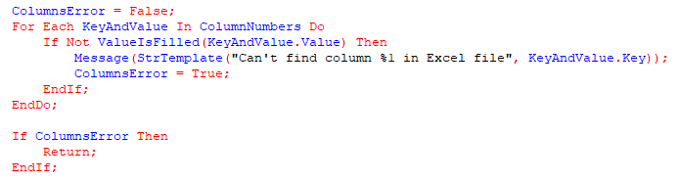
Why do I use a variable and break the code after the loop? To immediately notify the user about all missing columns, instead of notifying them one by one per loading attempt.
The next step is to iterate through the rows from the second to the number of rows, extracting text from the cells at the intersection of the current row and the columns whose numbers we found earlier. After that, I need to find a reference to the product by the extracted name using the FindByDescription() method, and it is better to search by exact match, because otherwise there is a chance to find a similar product by description (for example, for the name "Teapot", the following objects can be found: "Electric Teapot", "Aluminum Teapot", "Teapot", etc.). Now I check for the completeness of the value returned by the product search. If the product could not be found, I display a message to the user indicating the description by which the search was performed, otherwise I create a new record in the price register using the record manager. For the date I use the current date, which I get once before the loop, so that it is the same for all loaded records.
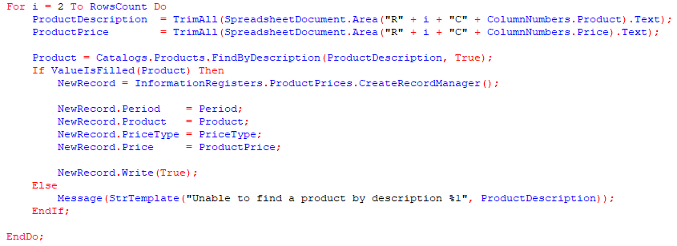
When recording, I pass True to the Replace parameter of the Write method of the register record manager. That is, if the day, product and price type match, the old record will be replaced by the new one. If it is necessary to leave the user the right to choose whether to replace old records or not, you can create a separate attribute, the value of which the user will manage from the form. Then this attribute should be passed to the parameter of the Write method.
If we talk about the applicability of such data processor in real work, it is worth noting that prices are not always set for the current date. Sometimes we need to set prices that will take effect from the beginning of the next month or another date. In order for the date of new prices to be not the current one, but any date chosen by the user, I create the Period attribute with the date type and change the code in the algorithm for filling the record manager. In order for this period to already be filled when starting work with data processor, I create the OnCreateAtServer event handler, in which I initialize the Period with the current date.
Next, I create a group on the form in which I place the Period and PriceType fields so as not to take up too much vertical space.
I update the configuration and run the data processor in Enterprise mode to check.
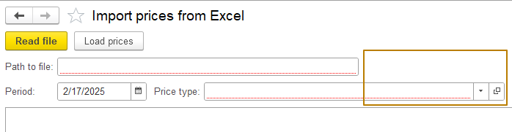
You can see that the form does not look nice - the group containing the period and the price type is much wider than the "Path to file" field, although in Designer mode the difference in width was minimal:
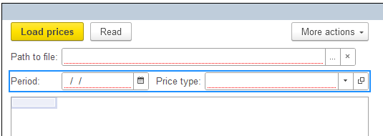
In order to have an idea of how the form will look in Enterprise mode during development, while also taking into account the different window sizes (which can change depending on the screen resolution, system scale, whether the window is in "Full Screen" mode, etc.), there is a "Test" button above the form element structure in the Designer:
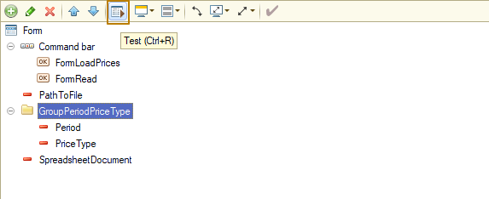
In the window that opens, you can see how the form elements behave with different window sizes (the window size can be changed)
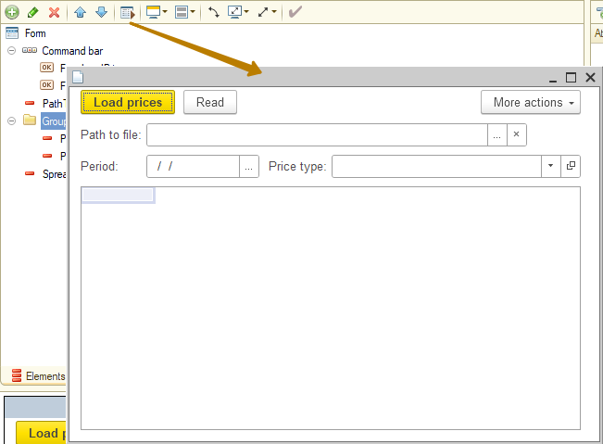
Currently, the "Price type" field is stretched horizontally when the form is stretched to a certain width, after which it stops stretching. In order to fix its width, I can use the "MaxWidth" property of the form field, which becomes available when the "AutoMaxWidth" flag is disabled:
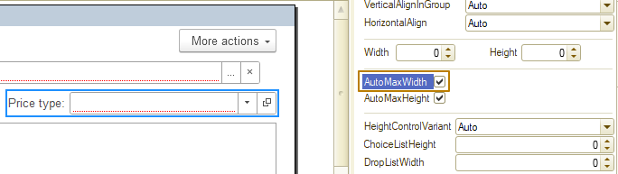
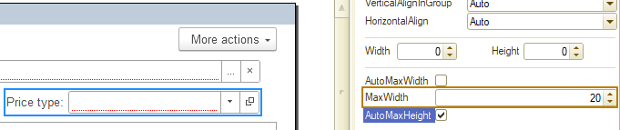
This field allows you to set the maximum width for an element/group, to which the element/group can be stretched if possible. If the form does not allow you to fit the specified width, the element/group width will be reduced automatically.
I check how the field now looks in the "Test" window:
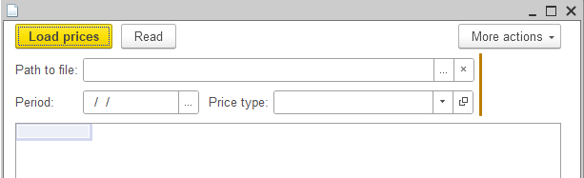
Now the width automatically changes to fit the width of the form, but not wider than the value I specified.
I return to testing the processing in Enterprise mode. The period is automatically filled with the current date. I select the path to the Excel file, then read the data from the file and click the download button. The program displays an error because I did not fill in the "Price type" field.
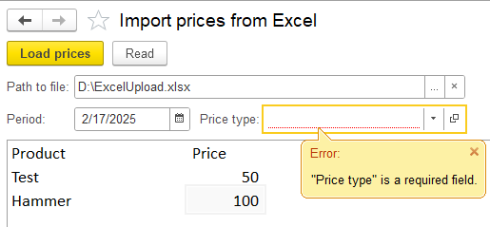
That's right, let's fix the error. I create the Wholesale and Retail price types and select the Wholesale price to load, then click the "Load prices" button again.
Now the program gives another error: "Unable to find a product by description Test", which says that the product with the name "Test" could not be found in the Products catalog, which is correct.
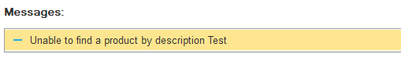
Next, I open the prices register to check if any records were loaded. As you can see, the loading was successful:

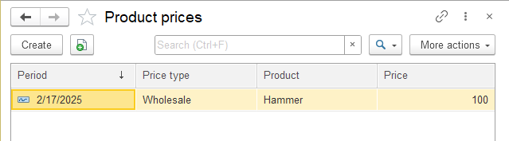
Of course, the data processor is not perfect, the loading algorithm can be improved so that at the end of the loading a message about the number of successfully loaded prices is displayed, you can also make changes so that the price type is read from a file, and not specified by a user, or combine both options with a user specifying the desired one using the radio buttons field. In addition, the processing does not provide for a situation where between selecting a file and reading it, the file could be deleted / moved / renamed, i.e. the file at the specified path no longer exists. We analyzed the latter situation when loading the logo in the Companies catalog item.
I will not perform any actions on the above or other improvements, you can practice improving them yourself, instead, I will tell you about the features of working with files in the client-server mode of working with the information base.
A developer must remember that when working in the client-server mode, the file, the path to which is specified in the local form (path at the disk) is often available either on the client or on the server. This happens because the client and server are usually physically located on different computers and systems. Therefore, a file located in a directory on the client computer, the path to which is specified as local, not network (for example, the local path looks like this "D:\Work", the network path looks like this: "\\Accountant-computer\Work"), is accessible from the client computer, but is not accessible from the server. In this case, the algorithm for reading data from the file into a spreadsheet document will lead to an error, since it is executed on the server, where the file will be searched for in the server's file system, not the client's. When specifying a network path, the same problem may occur, since the server may not have rights to the network path.
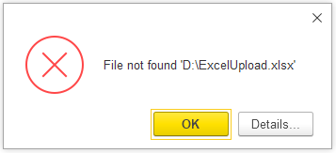
What should be done in this case so that the server can work with the file stored on the client?
The data of the selected file in binary data format must be placed in temporary storage and its address in temporary storage must be transmitted to the server, where it is extracted from the file. Then, on the server, you can create a temporary file name, then write the extracted binary data to the temporary file, read the file data into a spreadsheet document, and finally delete the temporary file.
First, I want to prevent the situation with separate file selection and reading, since the file could be changed between these actions. So I delete the PathToFile field, and move the code from its "StartChoice" event handler to the "Read" command handler, which I rename to "ReadFile":
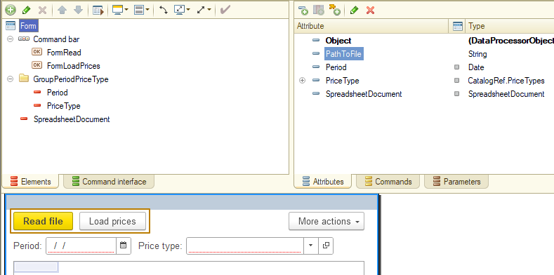
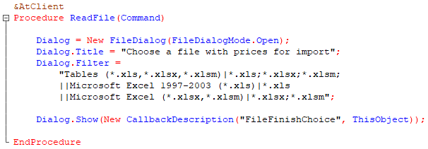
Now, after extracting the full path to the selected file, you can immediately call its placement in temporary storage for transmission to the server. To do this, I use the BeginPutFileToServer method, in which I must specify: a callback handler that will be called upon completion of placing the file in temporary storage, the path to the file being placed, and a unique form identifier that will be used when placing the value in temporary storage. A unique identifier is needed so that when the form is closed, the temporary storage with the identifier of this form is automatically cleared by the platform.
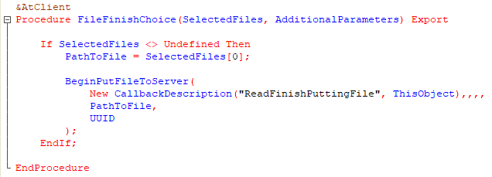
In the handler of the notification about placing a file in temporary storage, it is necessary to check the first parameter PlacedFileDescription to make sure that it is not equal to Undefined, since this would mean that the file placement failed. Then we can call the server procedure for reading the file, to which we should pass the address of the file in temporary storage, as well as the file extension, since it will be needed when creating a temporary file so that it is in Excel format and then reading it into a spreadsheet document. The file extension can be obtained from the property FileRef.Extension of the PlacedFileDescription parameter
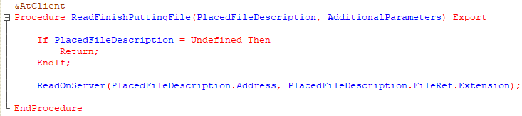
In the server procedure, I extract binary data from temporary storage at the address passed from the client, then generate a new name for the temporary file using the GetTempFileName() method, write binary data to the file at this path and read its data into a spreadsheet document.
After that, I no longer need the created temporary file, since its data is already in the spreadsheet document, so it is advisable to delete it immediately to avoid overfilling the disk space with unnecessary files (a file can weigh 5-10-20 MB, after loading several hundred such files, a noticeable part of the useful disk space will be occupied), for this I use the DeleteFiles() method, which is better to use inside the Try operator, since when deleting, an exceptional error may occur, which should be processed and written to the event log.
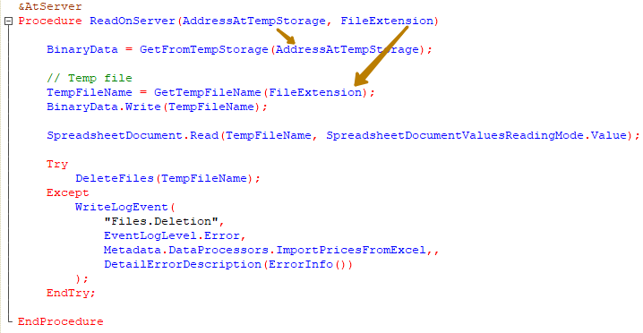
Information: in general, the platform itself deletes such temporary files at the end of the session, however, in the case of client-server work, the session for temporary files created on the server is considered to be the session of the 1C server, and not the client session, i.e. with continuous operation of the 1C server, files can accumulate over days or even weeks. Therefore, the syntax assistant for the GetTempFileName() method recommends deleting temporary files yourself.
This completes the work with processing the loading of prices from an Excel file.
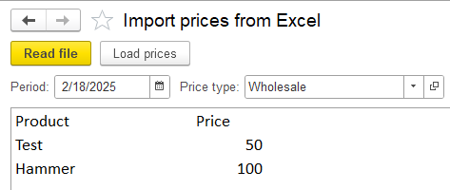
External data processors
Let's talk about external data processors. External data processor is a file with a certain structure with the .epf extension, which can be created in the Designer mode and implement almost everything in them that is in the built-in data processor. The difference is that the external data processor does not have a manager module, since only an object from the configuration can have an object manager.
Let's create an external data processor and look at its launch on behalf of the user in the Enterprise mode.
To create an external data processor, you need to click the "New" button from the "File" menu or "New Document" button on the "Configuration" panel in the Designer mode. In the window that opens, you should select "External data processor", after which the editor of the external data processor, which has not yet been saved to a file on the disk, will be opened. When saving for the first time, a system window will open to specify the name and path of the file where the external data processor will be saved as a file.
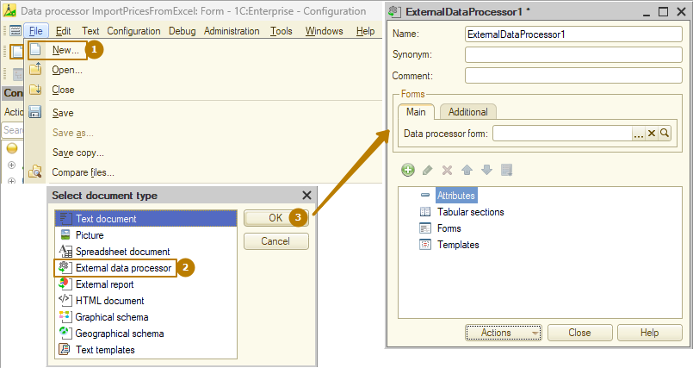
The work with an external data processor is done in the same way as with an object built into the configuration. I want to make a data processor that would fill in some objects with the necessary data. For example, a fairly common case is adding an attribute to a catalog/document, and the attribute must be required to fill in. Such a change can lead to a disruption in the program's functionality, since after the required attribute appears, it will not be filled in already existing objects, while the user can continue to work with such objects. For example, the user must fill in and post recent documents, but they cannot being posted after the update, when a required attribute was added to the metadata object.
In case of such changes, the developer must provide for the filling in of existing data so as not to disrupt the work of users. For this type of operations, we use the update handlers mechanism, which is part of the standard subsystem library (SSL) from 1C, which we will talk about in the following lessons, and in the absence of such a library in the configuration (like our configuration, which we are developing from scratch) or for other reasons, we also use external data processors, which can be launched on several information bases with a similar configuration, even for different clients without including them in the configuration.
Let's take a simple example - a task was received to modify the document Sales invoice and add the "PriceType" attribute to it, which has the type of the recently created catalog "PriceTypes". This attribute must be required to fill in, and the value must be filled in depending on the document date.
If the document date is earlier than the value specified by a user, one value must be set (also specified by the user), otherwise - another value (and it must also be specified by the user).
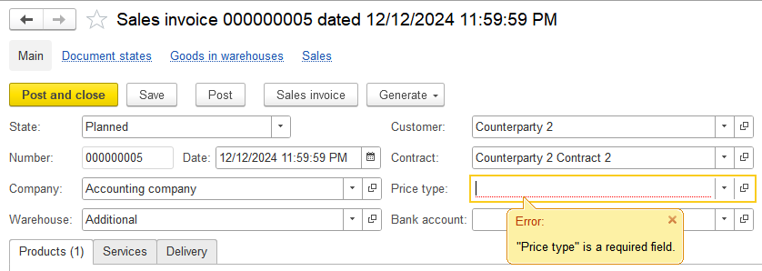
My task is to provide the user who will work with this data processor with the ability to select a cutoff date, as well as two types of prices: the first will be filled in documents before the specified date, and the second - after. And also add the "Fill price type" button, when clicked, the attribute in the documents will be filled in and the documents will be rewritten.
Or I can go a slightly different way and make the data processor more flexible so that it allows users to fill in the price type in documents for the selected period, then users will be able, for example, to fill in the Wholesale price type in documents for 2023, then select Retail price type and fill in for half of 2024, then select another price type and fill in the second half of 2024, and so on. Then I will need two fields with dates (or one field with the StandardPeriod type) and one PriceType field.
So, I created the data processor and its form. In the server procedure for processing the click of the documents filling button, I write a query to the DB to select all documents in a given period, and I additionally specify the filter by documents in which the PriceType attribute has not yet been filled in. This is necessary in case users have already filled in some of the documents from the moment the configuration is updated to the moment this filling processing is performed, in which case the processing will not affect such changes.
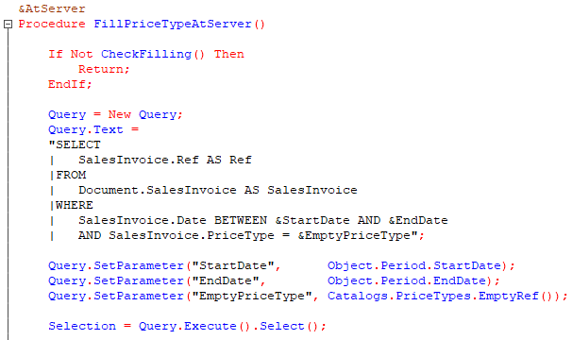
Next, I need to get each unfilled document object, fill in the price type, and write the document. If an error occurs, I need to write its details to the event log. I also want users to receive information about how many documents were processed and how many remained unprocessed (that is, the ones that errors occurred during the recording process) when the execution is complete. To do this, I initialize new variables NumberProcessed and NumberUnprocessed to 0, and in the loop I increase their values upon successful or unsuccessful processing of each document. When finished, I check if the value has changed, and if so, I display the appropriate message to the user.
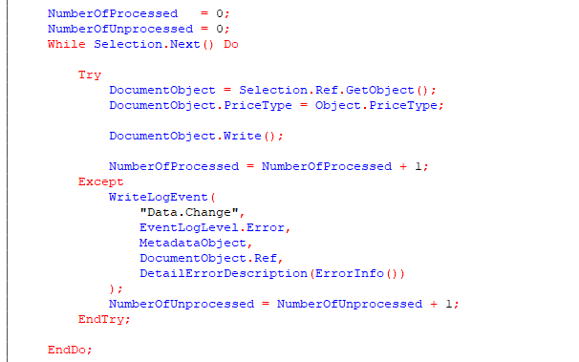
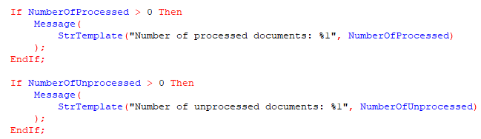
Now I need to save the data processor, and I don’t need to save the configuration or restart debugging, I just switch to Enterprise mode and open the data processor from a file:
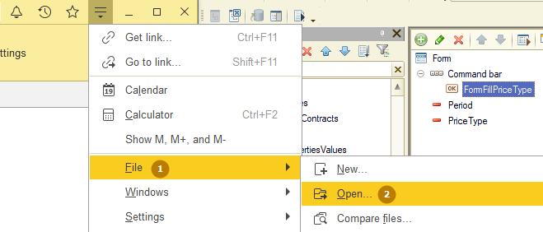
At the same time, the platform warns that you should open files only from trusted sources, because they can perform potentially dangerous actions. This is very important and therefore in the standard subsystems library there is a separate role for users that gives the right to open external reports (yes, reports can also be external) and data processors. Users who do not have this role cannot open reports and data processors from files.
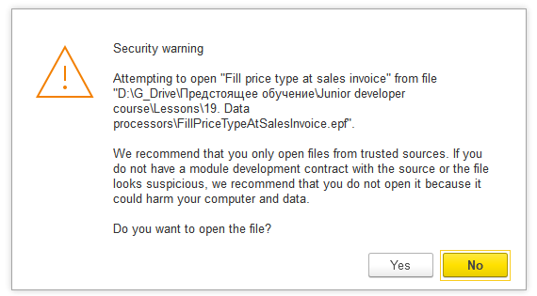
I start the processing of documents and upon completion I receive a message about the successful processing of 5 documents.
Finally, I will show how you can convert built-in reports and data processors to external ones and vice versa, as well as add external reports and data processors to the configuration.
To add an external report or data processor to the configuration, you need to right-click on the desired branch of metadata objects in the configuration tree and click the "Insert external report or data processor" button. If you need to save a built-in object to an external one, you should right-click on the desired object and click "Save as external report or data processor", to load a built-in object from an external one, you should click "Replace with external report or data processor".
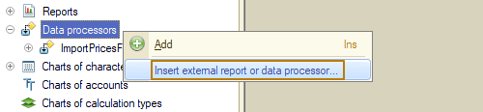
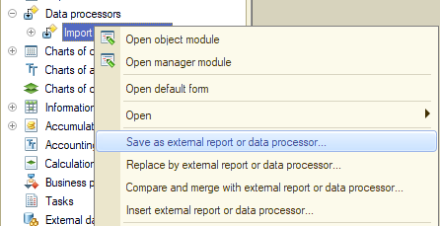
There is also a button for comparing and merging with an external report or data processor, which allows you to manually select individual parts and merge the built-in and external report/processing, and the result of such a merge will replace the built-in object.
As I said earlier, external reports and data processors do not have a manager module, so when saving an embedded object to an external one, you should take into account that the code from the manager module will disappear.
This is where we can finish our acquaintance with data processors.

